Physical Education Lesson for the Week
May 1st- 31st – National Sport and Fitness Month
May 26th-29th, 2020

- We have covered all the Muscles of the Month for the school year, we are going to continue to do a muscle of the week each week. Review the muscle with your child by saying what the muscle is for the week. Have them show you where it is on their body. Next, show them the picture on the slides to see if they were correct. Finally, explain what it is used for or have them explain what it is used for (attached you can use the slides/pictures to assist with your child).

- Continue Each Day During May to perform the activities on that specific day using your May activity calendar attached.

- Tuesday-Friday – Pick a day or choose multiple days during the week and do our virtual PE Field Day with your family. At the bottom of the lesson you will see the activities for field day and a scorecard. The rules for each field day event are provided and on the scorecard, you will be able to mark all the points collected during the events you choose. Have fun with this and be safe!

Be Safe, Be Healthy, Stay Active!
Shaler Area School District
Primary PE Department
Yours in Fitness and Health,
Mr. Chmielewski

Muscle of the Week

Muscle of the Week

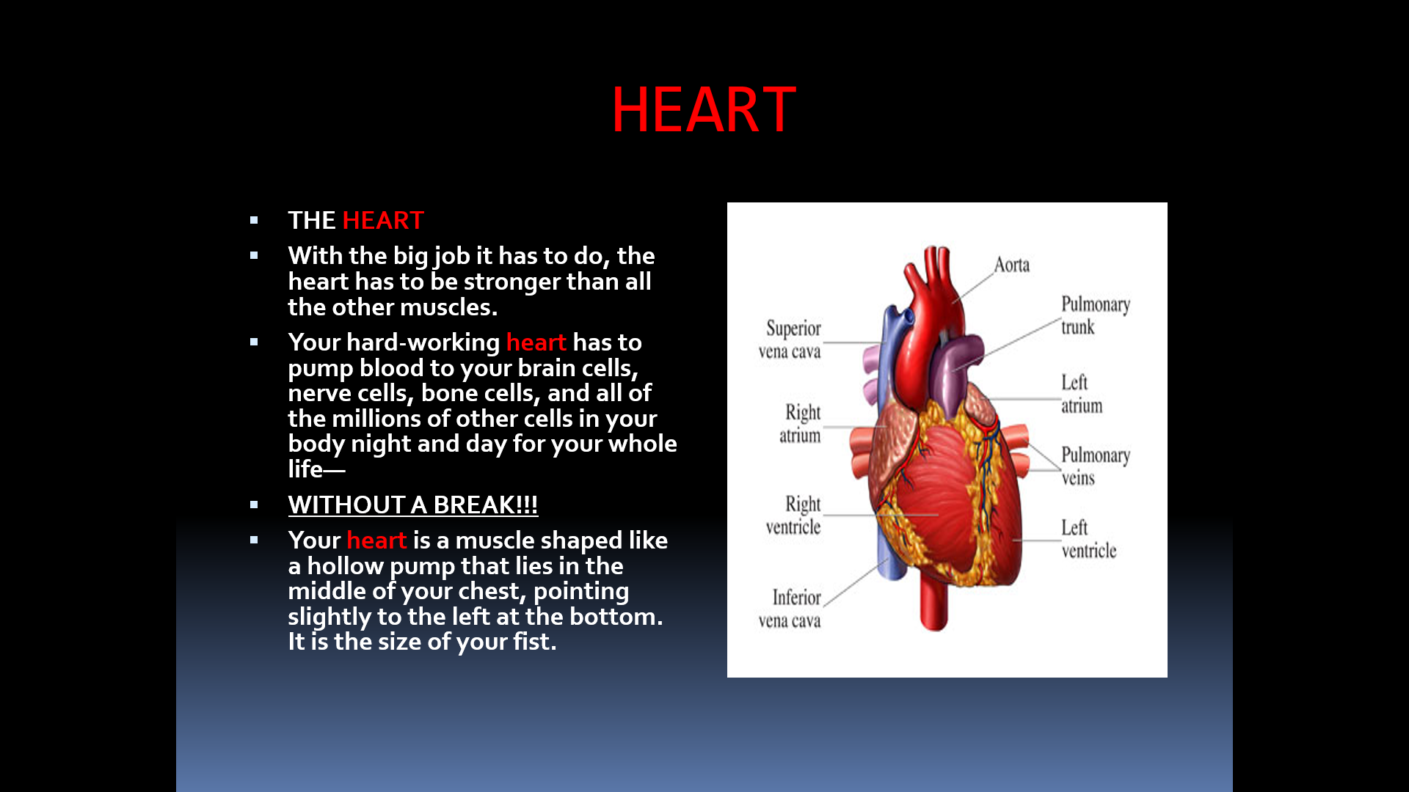
Function of the Heart

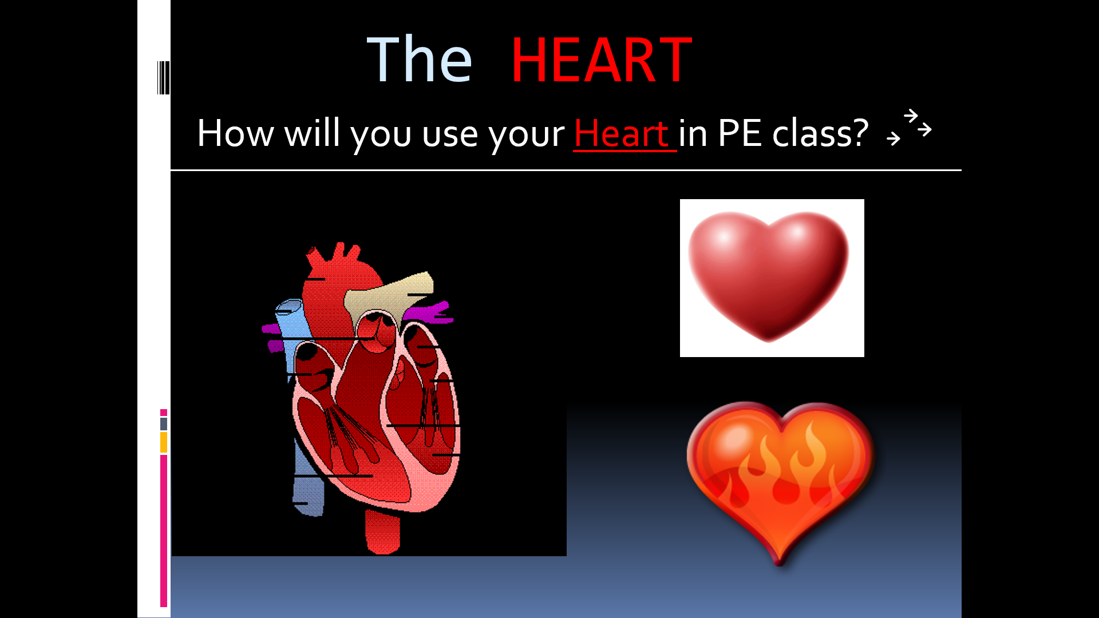
How do we use these muscles in PE?

We use the Heart in PE CLASS to test our cardiovascular endurance.

National Observances  ● May 1-7: National Physical Education and Sport Week ● May 4th: Star Wars Day  ● May 5th: Cinco de Mayo  ● May 6th :National Nurses Day ● May 10th: Mother’s Day |  |  |  |  | 1 Commercial Break  Can you hold a plank for an entire TV commercial break? | 2 Dribble Challenge  Dribble a ball 100 times with each hand. Can you successfully dribble 100 times with each hand while moving?
3 How Fast Can You Go?  Pick a distance and see how fast you can run the distance. | 4 Star Jumps  Jump up with your arms and legs spread out like a star. Do 10 then rest and repeat. | 5 Celebrate  Put your favorite song on and make up a dance or fitness routine! | 6 A Gratitude Attitude Write down something you’re thankful for and why. | 7 Inchworms  Keeping your legs straight place your hands on the ground, walk them into push-up position, and walk your legs up. | 8 Teacup Tip-ups  Place your hands on the ground and gently touch your forehead to the ground balancing your elbows on your knees. | 9 Musical Frogs  This game is just like musical chairs except players hop around like frogs and sit on lily pads (pillows).
10 Positive Talk  Be sure to talk to yourself today like you would talk to someone you love. | 11 Yoga  Yoga is a great way to relieve stress. Try Savasana, considered to be the hardest yoga pose! Fully relax & clear your mind. | 12 Wild Arms  As fast as you can complete: 10 Arm Circles front & back 10 Forward punches  10 Raise the Roof’s Repeat 3x | 13 Mindful Senses  What do you notice around you? Find:  5 things you see 4 things you feel 3 things you hear 2 things smell  1 thing you taste | 14 Crawl Like a Seal  Lie on your stomach, arms straight out front. Use your arms to pull your lower body along keeping your legs and back straight. | 15 Rock Paper Scissors Tag Meet in the middle, shoot, loser chases the winner back to safe zone. If tagged, join the other team.  . | 16 Family Mindful Snacking When eating a snack today, really pay attention to the taste, feel, sound, smell and look of the snack you’re eating. What do you notice?
17 Rock Paper Scissors Tag Meet in the middle, shoot, loser chases the winner back to safe zone. If tagged, join the other team. | 18 Chair Pose  Hold for 30 seconds, relax then repeat. | 19 Paper Plate Planks  In plank position with paper plates under your feet. Complete 30s each:  -mountain climbers -in and out feet  -knees to chest | 20 Commercial Break  Can you hold a plank for an entire TV commercial break? | 21 Jump, Jump  Jump side-to-side over an object or line for 1 minute straight. Go again but jump front to back. Repeat each jump twice. | 22 Positive Talk  Be sure to talk to yourself today like you would talk to someone you love. | 23 Play Catch  Grab any kind of ball and play catch with a family member. Keep your eyes on the ball and catch it with your hands not your body.
24 Before Bed Breathing  While lying in bed, place your hands on your stomach and pay attention to the up and down of your belly as you breathe. | 25 Crane Pose  Here’s a challenge! Put your hands on the ground, lean forward & balance your knees on your elbows. | 26 Step Jumps  Find a step or a bench and jump up and down 50 times. Be careful. Take a break if you need to. | 27 A Gratitude Attitude Write down something you’re thankful for and why. | 28 Wake and Shake  As soon as you get out of bed shake your body any way you like for 10 seconds. Are you up now? Good! Now jump up and down 10 times. | 29 Walls  Face each wall in a room and do a different exercise for 30 seconds  -side shuffle  -grapevine to left then right -wide stance punches  -vertical jumps | 30 How Fast Can You Go? Pick a distance and see how fast you can run the distance.
31 Wild Arms  As fast as you can complete: 10 Arm Circles front & back 10 Forward punches  10 Raise the Roof’s Repeat 3x | SHAPE America recommends school-age children accumulate at least 60 minutes and up to several hours of physical activity per day. Each bout of physical activity should be followed by cool-down stretches that help reduce soreness and avoid injury. Happy exercising!  Reproduced with permission from the Society of Health and Physical Educators (SHAPE America) https://www.shapeamerica.org/publications/resources/teachingtools/teachertoolbox/activity-calendars.aspx

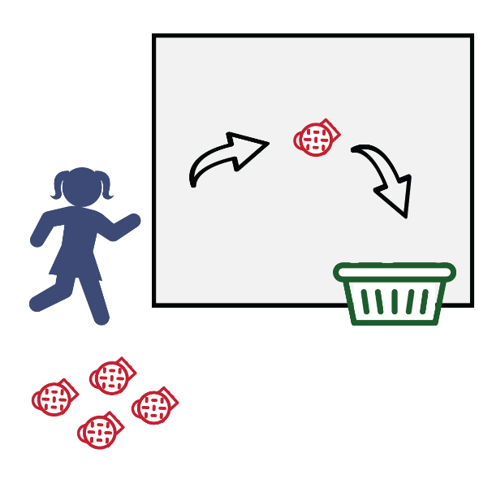
BACKBOARD BANK IT

Get Ready: 5 Large Sock Balls, Laundry Basket or Bucket, A Wall

Get Set: Roll up the socks to make sock-balls. Place the basket or bucket against the wall. Mark a distance 5’ – 10’ from the basket.

GO!
● This event is called Backboard Bank It.
● The object of this game is to score as many points as you can in 1 minute.
● Do that by tossing the sock balls off of the wall and into the basket. You MUST use the wall as your backboard and bank it into the basket.
● Score a point for every sock that is banked into the basket.
● Write your score down on the official Field Day Score Card.

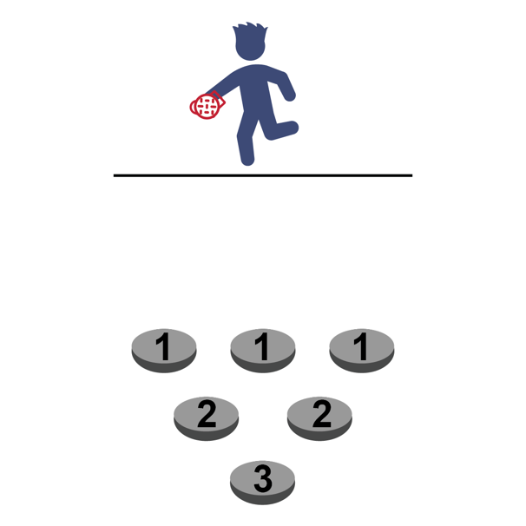
BOWL BALL

Get Ready: 6 Bowls, 1 Sock Ball, Paper & Pencil to Tally Score

Get Set: Set the bowls on the floor in a triangle pattern 3-4 inches apart. Put a piece of paper with the point total in the bottom of
each bowl. Mark a throwing line 6-8 ft. away. Hint: Big bowls are easier than small bowls!

GO!
• The object of the game is to see how many points you can score in 1-minute.
• You do this by tossing the sock ball into the bowls and scoring points based upon where they land.
• After each throw, retrieve the sock ball and hustle back and throw again. • If the sock lands in a bowl, use the pencil and paper to tally the points for
that bowl.
• After 1-minute, calculate your tally and write your total number of points on the official Field Day Score Card.

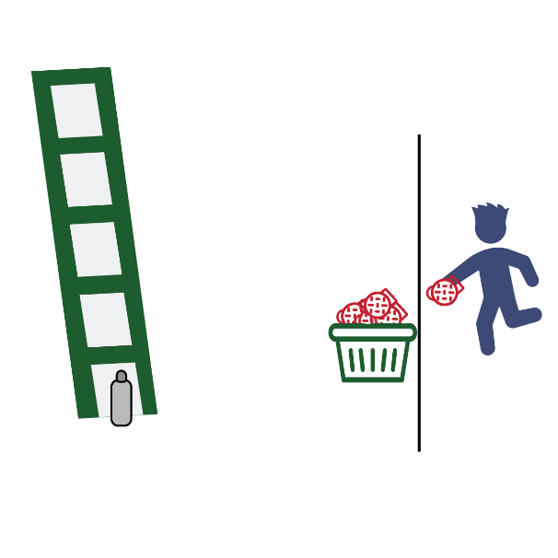
CLIMB THE LADDER

Get Ready: 6’ Ladder, 6-12 Sock Balls, Laundry Basket, Empty Water Bottle
Get Set: Set up the ladder. Place the water bottle on the floor under the first rung. Mark a throwing line 10-15 ft. away. Place the laundry basket on the throwing line. Put all the sock balls inside the basket.
GO!
• “Climb the ladder” using the fewest throws.
• Start with the bottle on the floor under the first rung.
• Throw sock balls at the bottle until you knock it over. Take your time, this is not a race.
• Move the bottle up one rung each time you knock it off the ladder. • If you run out of sock balls, collect them and continue.
• Count all of your throws on every step of the ladder. How many throws does it take to knock the bottle off of the top rung of the ladder?
• Write the total throws on the official Field Day Score Card.

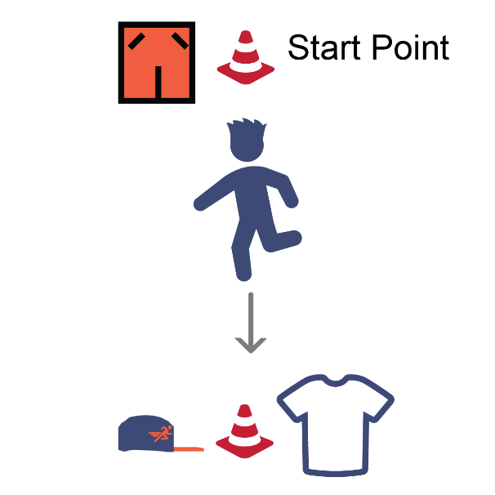
CLOTHES RELAY

Get Ready: Oversized Tee Shirt, Oversized Shorts, and a Hat; Items to Mark Start/Check Points (cones, socks, plastic cups, etc.); Clock or Stopwatch

Get Set: Set up an area to move in by making a starting point and a check point. Distance can be 15 to 30 walking steps from point to point. Put the shirt and hat on the check point opposite from the start point, put
the shorts on the start point.

GO!
• This event is called the Clothes Relay. The object of this game is to see how fast you can go from point to point putting on the clothes and then finishing at the starting point.
• On the start signal, jog down to the check point and put on the t-shirt, then jog back to the start point and put on the shorts, then jog back to the check
point and put on the hat, then jog back to finish at the start point. •
Start the Clock on “Go” and stop when you cross the finish
with all the clothes on.

COIN FLIP 400-METER DASH Get Ready: 1 Coin
Get Set: Find an open space with enough room to run in place safely. Hold the coin in your hand – be ready to flip it.

GO!
● This event is the Coin Flip 400-Meter Dash!
● The object is to run 400 running steps as fast as you can. Remember, you’re running in place. Your feet move, but you stay in one spot.
● On the start signal, flip the coin. Let it land flat on the floor. If it lands on “heads” run 20 running steps and then flip the coin again.
● If the coin lands on “Tails” do not run. Flip again until it lands on heads.
● Count your steps out loud. When you get to 400, time stops, and the dash is over.
● Record your time on the official Field Day Score Card.

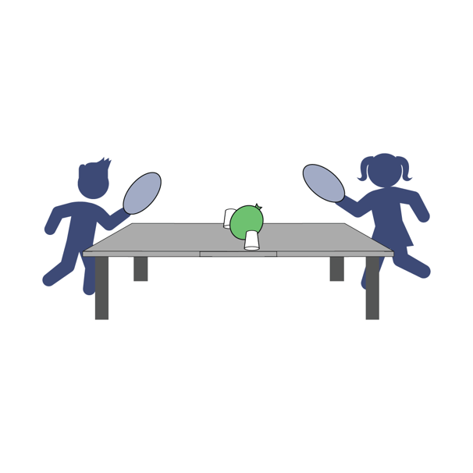
FAN-A-WAR

Get Ready: 1 Paper Plate (Piece of Cardboard or a School Folder) per Player, Center Line (2 Shoes or Cups will work) 1 Ping Pong Ball or a Balloon

Get Set: Create a center line on a table or the floor. Place the balloon or ball on the center line. Both players across from each other
with the centerline in between them.

GO!
● This event is called Fan-a-War.
● The object of this game is to keep the ball on the opponent's side of the center line. You will have 1 minute.
● On the start signal, begin fanning the ball toward your opponent’s side of the center line and away from your side.
● Continue for 1 minute. Score 5 points if the ball is on your opponent’s side.
● Play and score 2 rounds and then write your score down on the official Field Day Score Card.

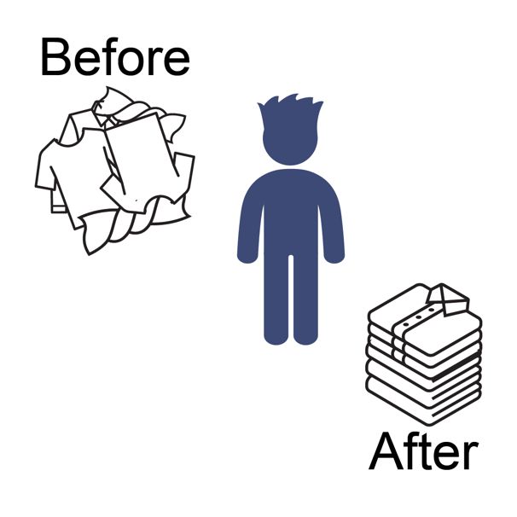
FAST FOLDER

Get Ready: 10 Clothing Items from a Laundry Basket for Each Player

Get Set: Place 10 items from your laundry basket in a pile next to you.

GO!
● This event is called Fast Folder.
● The object of this game is to score points by folding each item (shirt, pants, shorts, etc.). You have 1 minute to fold as many as possible.
● On the start signal, begin folding each piece of laundry.
● Score 1 point for each piece of laundry folded in one minute. Max 10 points.
● Write your score down on the official Field Day Score Card.

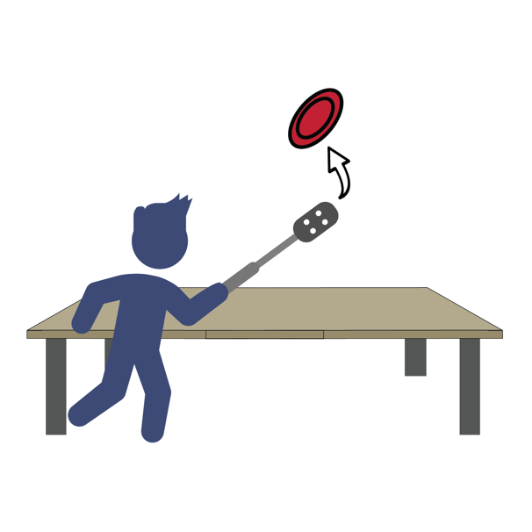
FLIP YOUR LID

Get Ready: Kitchen Spatula, 1 Tupperware/Plastic Lid

Get Set: Place the lid facing up on a table or floor. Get your spatula ready for some lid flipping!

GO!
● This event is called Flip Your Lid.
● The object of this game is to flip your Tupperware lid upside down to earn points.
● Place the lid facing up on the table or floor, then slide the spatula under and flip the lid in the air. Let it land flat on the table or floor.
● Score a point for every lid that you flip upside down (0 points if it lands right-side up).
● Quickly reset the lid each time you flip it.
● You will have 1 minute to see how many times you can flip the lid upside down.
● Write your score down on the official Field Day Score Card.

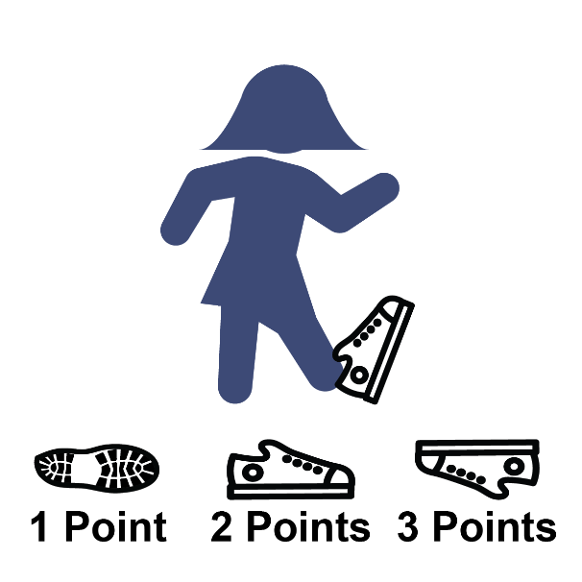
IF THE SHOE FITS

Get Ready: 1 Tennis Shoe, Spacious Area, Clean Feet

Get Set: Make sure you have plenty of unobstructed space around you.

GO!
• How many points you can score in 1-minute? • Put your foot partially into the tennis shoe.
• On the start signal, flip the shoe into the air. • Score as follows:
1 point = shoe lands on its side
2 points = shoe lands right side up (sole of the shoe on the ground)
3 points = shoe lands perfectly upside down (no sides touching the ground)
0 points = if the shoe hits you in the head or knocks over a lamp. • Write your total number of points on the official Field Day
Score Card.
• Go wash your foot.

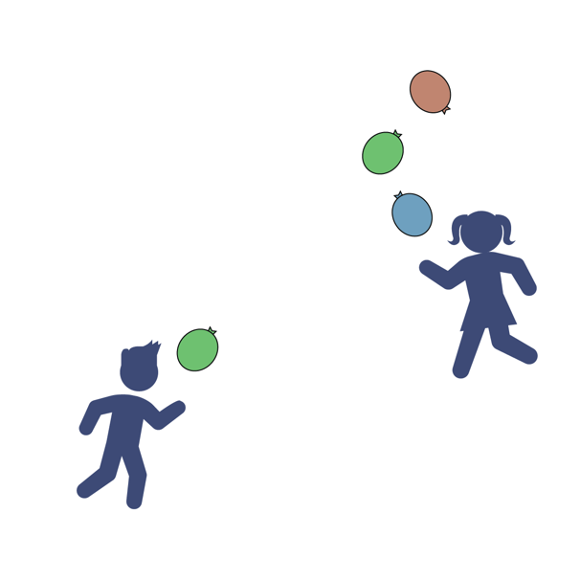
KEEP IT UP Get Ready: 1–3 Balloons Per Player – Blow Them Up
Get Set: Clear a 10’ indoor or outdoor space. Start with 1, 2 or 3 balloons.

GO!
● This is Keep It Up. The object is to strike the ball(s) up using your hands as many times as you can in 1 minute.
● Don’t let it (them) hit the floor.
● On the start signal, strike the balloon(s) upward with your hands and count how many hits you can score in 1-minute.
● If using multiple balloons, alternate striking each balloon. Don’t strike the same balloon twice.
● If the balloon hits the floor, pick it back up and continue. ● On the stop signal, record your score on the official
Field Day Score Card.

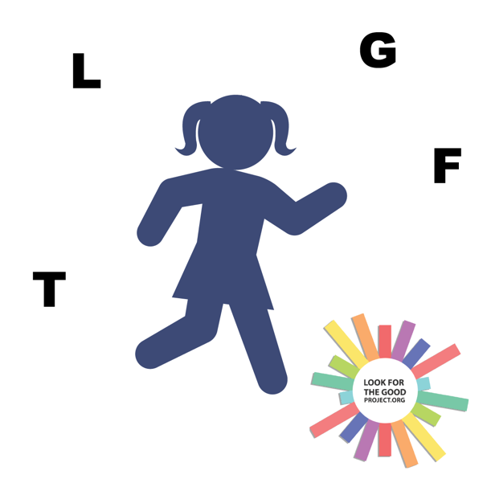
LOOK FOR THE GOOD Get Ready: An Object to Mark Your Home Base
Get Set: Mark a Home Base anywhere in your house. You will be bringing objects back to this spot.

GO!
● This event is called Look for the Good!
● The object is score points by finding 4 objects in your house (1 at a time) that start with the letters L–F–T–G (Look For The Good).
● You have 1 minute to find them all.
● Score 1 point for each object and a bonus point if you find all 4 (maximum 5 possible points).
● On the start signal, leave home base and go find an object that starts with the letter L. When you find it, return the object to home base before
looking for the next object. Continue until you find all 4 items, or time runs out.
● Record your score on the official Field Day Score Card.

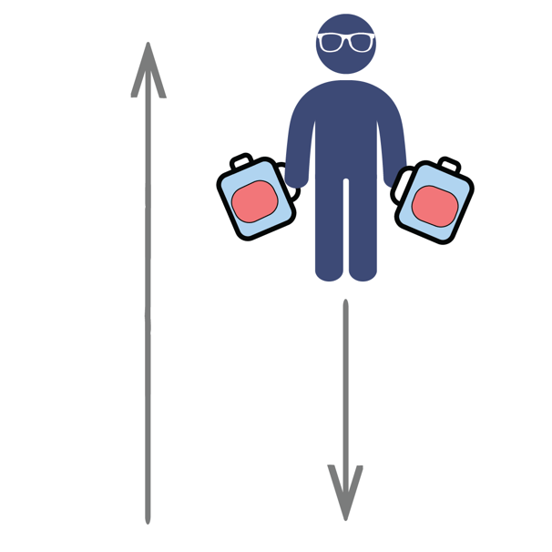
MILK JUG RELAY

Get Ready: Two 1-Gallon Milk Jugs, Items to Mark Start/End Points (cones, socks, plastic cups, etc.), Clock or Stopwatch

Get Set: Set up an area to move in by making a starting point and ending point. Distance can be 15 to 30 walking steps from beginning to end. Fill two used 1-gallon milk jugs with water (¼, ½, or full) and place at a start spot.

GO!
• This event is called the Milk Jug Relay. The object of this game is to carry the milk jug across the room as many times as you can.
• You get 1 point for each full length you travel.
• Add extra challenge by carrying two milk jugs at once. • You have 1 minute to complete the challenge.
• Write your score down on the official Field Day Score Card
VIRTUAL PE FIELD DAY SCORECARD
Each participant needs 1 scorecard. Choose a minimum of 5 events or try them all.
If you don’t have all the materials for at least 5 activities, then try as many as you can with the equipment available to you.
Participant Name: __________________________________________________________________
3 OPEN National Field Day Rules:
BE SAFE | HAVE FUN | SPIRIT OF THE GAME
Spirit of the Game (noun) An overarching concept that places the responsibility of fair play on each player. Respect, adherence to rules, and the joy of play are valued over competition.

School Name: ______________________________________________________________________

Event | Attempt #1 | Attempt #2 | Personal Best
Backboard Bank It
Bowl Ball
Climb the Ladder
Clothes Relay
Coin Flip 400-Meter Dash
Fan-A-War
Fast Folder
Flip Your Lid
If the Shoe Fits
Keep It Up
Look for the Good
Milk Jug Relay
Have Fun with this and send your PE Teacher some pictures, so we can see how you are doing at home. Good Luck

